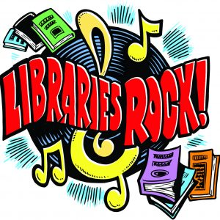

ALMONT DISTRICT LIBRARY SUMMER READING PROGRAM
All performances require pre-registration which opens on Wednesday, June 20th @ 10am in person or 12pm by phone.

2018 SRP Performances Are On Wednesdays
July 11 The Music Lady 11am & 1pm
July 18 Cameron Zvara 11am & 1pm
July 25 The Storytellers 11am & 1pm
August 1 Joel Tacy 11am & 1pm
August 8 Science Alive! 11am ,12:30& 2pm

The Music Lady
Music is in the Air Libraries Rock! Professional musician Beverly Meyer’s interactive show with movement and music, as well as hands-on instrument play!
Cameron Zvara
Comedy & Magic: Cameron’s show is JAM PACKED with magic, comedy, juggling and tons of audience participation!
The Storytellers
Rhythm, Rhyme, Reading Time: Features musical selections, hands-on fun with musical instruments from around the world, a short interactive poem and a hilarious musical skit! A wonderful chance for everyone to get up and move!
Joel Tacy
Page Rocker Magical Comedy Show: Strum, drum, rock & roll with Punk Rock Joel featuring magical & musical surprises, wacky stunts, and lots of audience participation.
Science Alive-Live Animal Presentations
A biologist and a collection of exotic critters invade the library attracting curious kids of all ages! Hands-on contact with parrots, turtles, snakes or maybe a chinchilla is sure to stimulate further learning.

