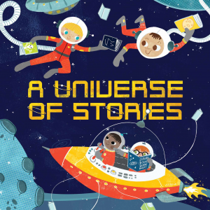

ALMONT DISTRICT LIBRARY SUMMER READING PROGRAM 2019
All performances require pre-registration which opens on Wednesday, June 19th @ 10am

2019 SRP Performances
Wednesday June 26 The Music Lady 11am & 1pm
Wednesday July 10 Kevin Kammeraad 11am & 1pm
Wednesday July 17 The Storytellers 11am & 1pm
Thursday July 25 Cameron Zvara 10am ONLY
Wednesday July 31 Science Alive! 11am ,12:30& 2pm
Wednesday August 7 End of Summer Party 11am

The Music Lady
Universe of Story-songs: Professional musician Beverly Meyer’s interactive exploration of space and sounds for children and families! With guitar in hand Beverly encourages even the most timid to join in!

Kevin Kammeraad & Cooperfly Puppets
Wimee Dreamed: Join Kevin and his puppets Wimee, Siblee Alexander, and more in this playful, musical, story-adventure filled with puppetry, wordplay, intergalactic travel, and creative technology!

The Storytellers
A Universe of Music & Stories: Features musical selections, hands-on fun with musical instruments from around the world, a short interactive poem and a hilarious musical skit! A wonderful chance for everyone to get up and move!
Cameron Zvara

Comedy & Magic: Cameron’s show is JAM PACKED with magic, comedy, juggling and tons of audience participation!

Science Alive-Live Animal Presentations
A biologist and a collection of exotic critters invade the library attracting curious kids of all ages! Hands-on contact with parrots, turtles, snakes or maybe a chinchilla is sure to stimulate further learning.

End of Summer Reading Party
Celebrate the end of Summer Read Program with water balloons, sidewalk painting, create a tie dy shirt and more! Pizza and refreshments will be provided.

